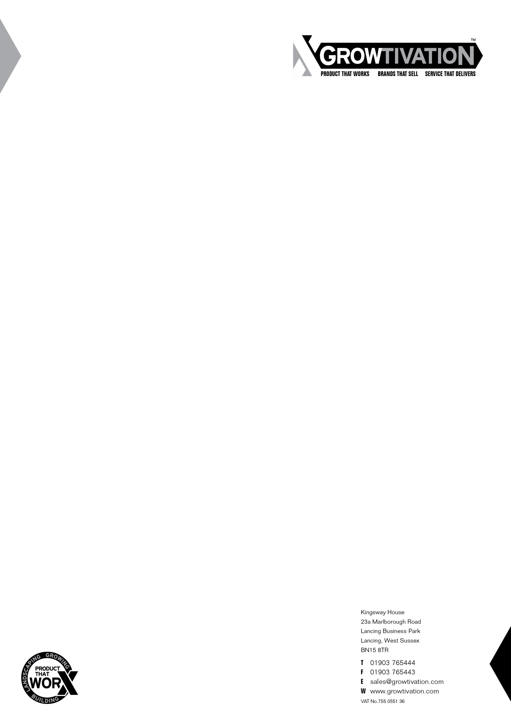

TECHNICAL DATA SHEET


DESCRIPTION

Landtex is a spunbond non-woven landscape fabric manufactured from 100% virgin polypropylene giving excellent durability and optimum quality.

APPLICATIONS

Landtex is a medium duty landscape fabric, typically used for weed suppression in a variety of applications, including;
- Flower/landscaped borders.
- Decking
- Planting schemes/beds
- Rockeries and scree gardens

PROPERTIES | UNIT | VALUE
Tensile Strength  (MD = Machine Direction CMD = Cross Machine Direction) | Mpa | MD = 4.97  CMD = 3.86
Elongation  (MD = Machine Direction CMD = Cross Machine Direction) | % | MD = 212.02  CMD = 234.58
Tensile Load  (MD = Machine Direction CMD = Cross Machine Direction) | N | MD = 134.25  CMD = 104.25
BK Load  (MD = Machine Direction CMD = Cross Machine Direction) | N | MD = 124.25  CMD = 97.0
Mass per unit area | g/m² | 70.00
Thickness | mm | 0.54
Size(s) | m | 1 x 15, 1 x 50, 2 x 25, 2 x 50, 1 x 100, 1.5 x 100, 2 x 100

The information contained in this data sheet replaces any previous information and all specifications and technical data appearing here must be used as guidelines, since they correspond to average values tested at laboratory. It is the responsibility of all users to satisfy themselves that the above data is current. This technical data sheet does not offer any warranty (express or implied) regarding the suitability of any product for your use as site conditions and requirements can vary. Growtivation reserves the right to alter product specifications and technical data without prior notice.

