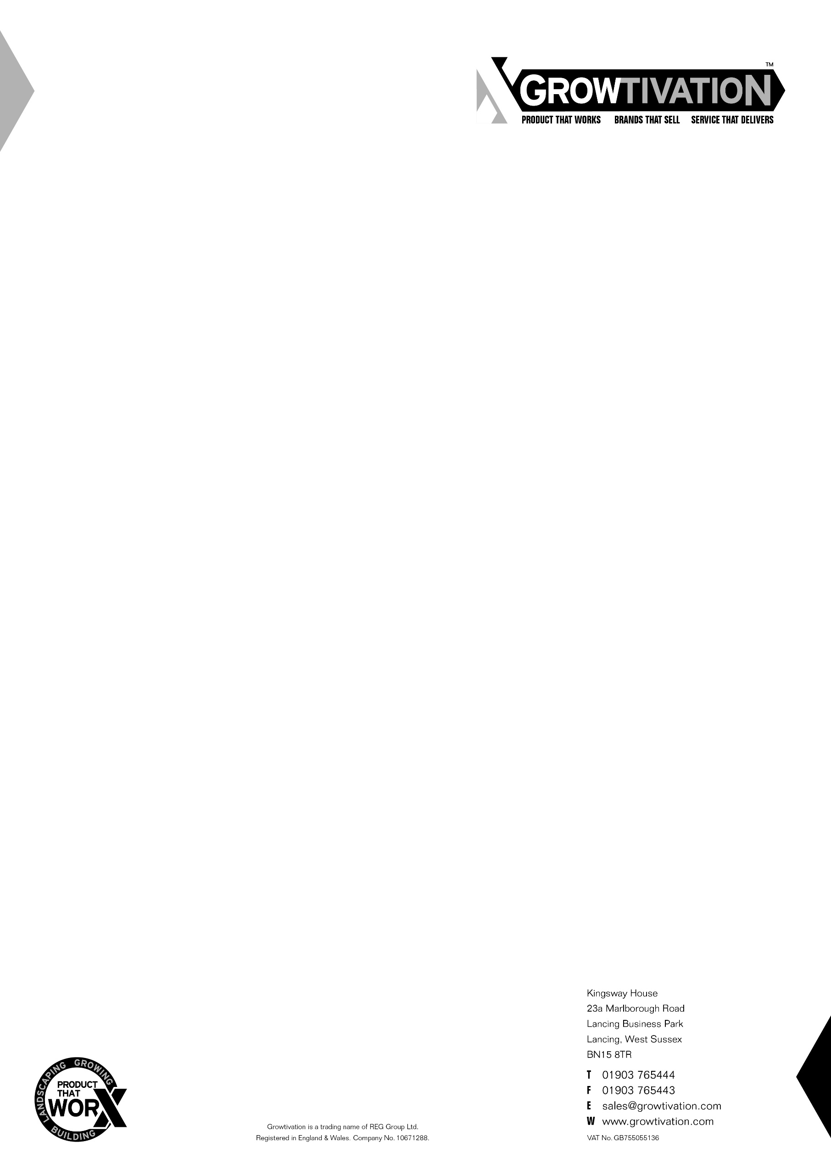

TECHNICAL DATA SHEET
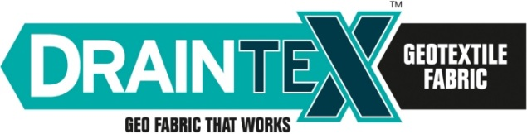

DESCRIPTION

Draintex is a non-woven geotextile fabric manufactured from 100% virgin polypropylene fibres giving excellent durability and mechanical resistance.

APPLICATIONS

Draintex is typically used for ground stabilisation and drainage/filtration in groundwork, civil engineering, landscape and building works. It can be used for separation, filtration, drainage and reinforcement in a variety of applications including;
- Roads and driveways
- Highways
- Railway construction
- Car parks and areas of hardstanding
- Paved areas
- Land drains, soakaways and SUDS installations.

PROPERTIES | TEST METHOD | UNIT | VALUE | TOLERANCE
Tensile Strength  (MD = Machine Direction CMD = Cross Machine Direction) | EN ISO 10319 | kN/m | MD = 4.60  CMD = 5.20 | - 0.60  -0.68
Elongation  (MD = Machine Direction CMD = Cross Machine Direction) | EN ISO 10319 | % | MD = 40.00  CMD = 60.00 | +/- 10.00  +/- 15.00
Dynamic Perforation Resistance (Cone Drop) | EN ISO 13433 | mm | 45.00 | + 9.00
Static Puncture Resistance (CBR) | EN ISO 12236 | N | 800.00 | - 80.0
Characteristic Opening Size (Pore Size) O₉₀ | EN ISO 12956 | µm | 120.00 | +/- 36.00
Water Flow/Permeability | EN ISO 11058 | m/s | 0.13 | +/- 0.04
Mass per unit area | EN ISO 9864 | g/m² | 80.00 | +/- 10.00%
Thickness under 2 kPa | EN ISO 9863-1 | mm | 0.50 | +/- 20.00%
Size(s) | - | m | 1 x 10, 2 x 25, 2 x 50 | -
Durability | EN ISO 12224 | Can be exposed up to 1 day
Oxidation Resistance | EN ISO 13438 | Predicted to be durable for a minimum of 25 years in natural soil with 4 < pH < 9 and temperatures < 25⁰C

The information contained in this data sheet replaces any previous information and all specifications and technical data appearing here must be used as guidelines, since they correspond to average values tested at laboratory. It is the responsibility of all users to satisfy themselves that the above data is current. This technical data sheet does not offer any warranty (express or implied) regarding the suitability of any product for your use as site conditions and requirements can vary. Growtivation reserves the right to alter product specifications and technical data without prior notice.

1213

