PRODUCT DATA SHEET

Coping upstand for left-hand side, parapet walls / roofs
240mm-660mm, coping widths

Status: 16.07.2026
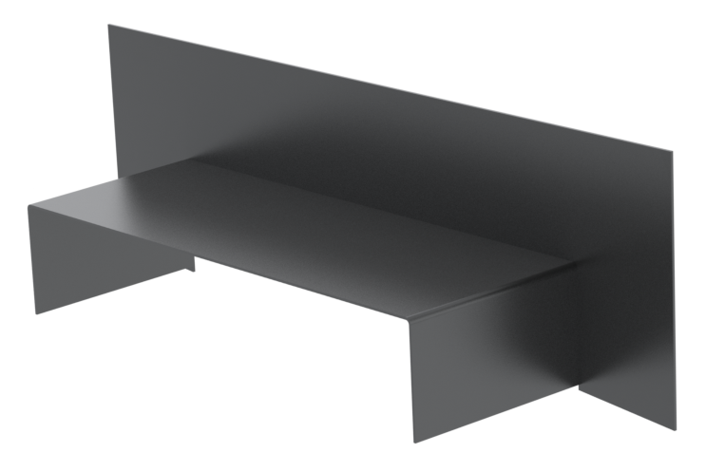


SLOPE

A

100mm

Designation |  | Coping upstand for left-hand side for parapet walls / roofs
Description |  | Aluminium coping upstand LHS, polyester powder coated
Product area |  | Roof
Product category |  | Coping
Material |  | 2mm aluminum, polyester powder-coated
Length |  | 100mm
Customs tariff number |  | 76042990
Code | Dim A (mm) | Wall width range (mm) | Material thickness (mm)
CAP-UPL-240 | 240 | 150-180 | 2.0
CAP-UPL-300 | 300 | 180-240 | 2.0
CAP-UPL-360 | 360 | 240-300 | 2.0
CAP-UPL-420 | 420 | 300-360 | 2.0
CAP-UPL-480 | 480 | 360-420 | 2.0
CAP-UPL-540 | 540 | 420-480 | 2.0
CAP-UPL-600 | 600 | 480-540 | 2.0
CAP-UPL-660 | 660 | 540-600 | 2.0

Various colours options are available. Please see pricelist.

This product data sheet reflects the current stage of development of our products and will be superseded upon release of a newer edition. Please ensure you are referring to the most up-to-date version of this document.

Our warranty and liability obligations apply only to goods supplied in accordance with our current terms and conditions of sale. Please follow all relevant installation, application, and storage guidelines when using this product.

All information is provided without guarantee and is subject to technical modification without prior notice. Product images are for illustration purposes only and may differ from the product supplied. Please dispose of all materials responsibly and in accordance with UK environmental regulations.

