PRODUCT DATA SHEET

Coping external corner for parapet walls / roofs
240mm-660mm, Coping widths

Status: 16.07.2026

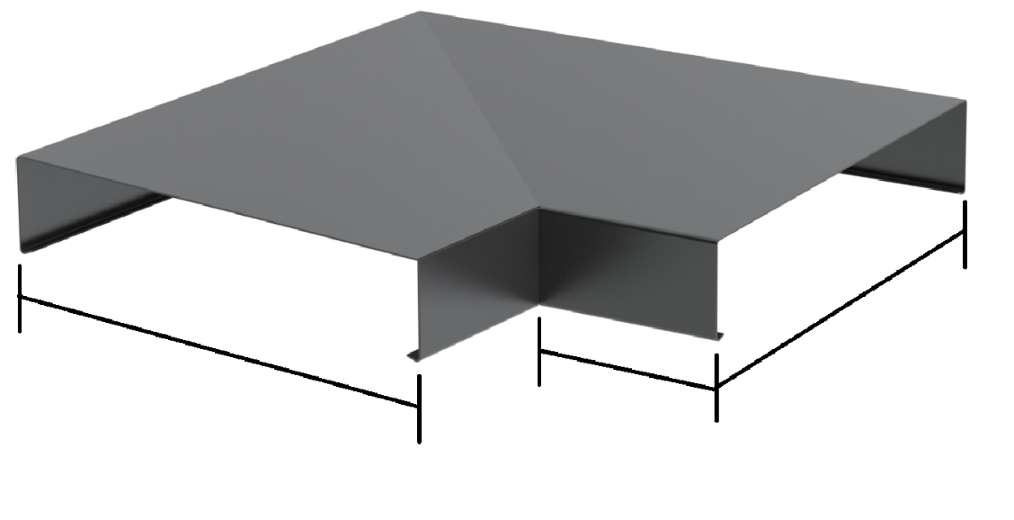
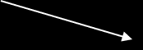

SLOPE

A
A
200mm

Designation |  | Coping external corner profile for parapet walls / roofs
Description |  | Aluminium external corner 90° coping, polyester powder coated
Product area |  | Roof
Product category |  | Coping
Material |  | 2mm aluminum, polyester powder-coated
Length |  | 200mm x 200mm
Customs tariff number |  | 76042990
Code | Dim A (mm) | Wall width range (mm) | Material thickness (mm)
CAP-EXC-240 | 240 | 150-180 | 2.0
CAP-EXC-300 | 300 | 180-240 | 2.0
CAP-EXC-360 | 360 | 240-300 | 2.0
CAP-EXC-420 | 420 | 300-360 | 2.0
CAP-EXC-480 | 480 | 360-420 | 2.0
CAP-EXC-540 | 540 | 420-480 | 2.0
CAP-EXC-600 | 600 | 480-540 | 2.0
CAP-EXC-660 | 660 | 540-600 | 2.0

Retention bracket and a corner retention bracket are required to secure the coping in place. Please note that retention brackets are sold separately. Please refer to retention bracket data sheets for more information.

Various colours options are available. Please see pricelist.

This product data sheet reflects the current stage of development of our products and will be superseded upon release of a newer edition. Please ensure you are referring to the most up-to-date version of this document.

Our warranty and liability obligations apply only to goods supplied in accordance with our current terms and conditions of sale. Please follow all relevant installation, application, and storage guidelines when using this product.

All information is provided without guarantee and is subject to technical modification without prior notice. Product images are for illustration purposes only and may differ from the product supplied. Please dispose of all materials responsibly and in accordance with UK environmental regulations.

